Name:  Class: | ____________________________________  ________________ |  | Date: ___________
 | Year 11 Essential Mathematics Unit 2  SCORE:  / 26  Mini Test 2.1 2018  Topic – Data analysis and Displays  Full working out MUST be shown to get full marks for each question.
Total Time: | 30 minutes
Weighting: | 1%
Equipment: | To be provided by the student: Pen, pencil, ruler, scientific calculator,1 single sided page of A4 notes

Question 1
The shapes of the graphs below can be described using the words “positive Skew”, Negative Skew”, “symmetrical” and “Bimodal”. Underneath each graph, write the most appropriate term. [3 marks]

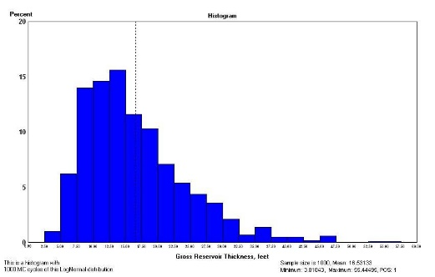
- B)
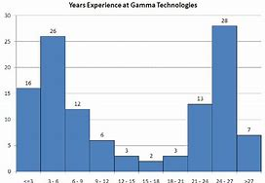

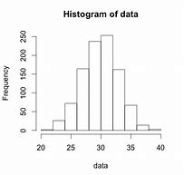
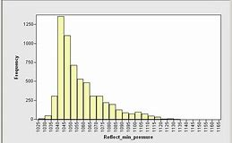
C) D)

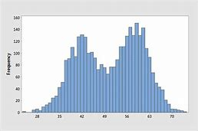
E) F)
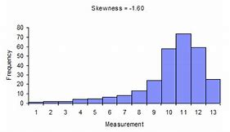

Question 2
These are the waiting times (in minutes) for the service when calling customer service of two phone companies:

Telstra: 10, 7, 6, 8, 7, 5, 6, 9, 7, 3, 8, 8, 9, 7, 9, 7, 9, 8
Vodafone: 10, 5, 9, 9, 9, 10, 11, 9, 8, 7, 9, 7, 7, 6, 8, 11, 11

- Find the 5 Number Summary for each data set. [5 marks]

- Construct a box and whiskers plot for each data set on the same number line below.
[10 marks]


- Telstra claims that its waiting times are generally lower than those of Vodafone. Using the data, explain whether Telstra’s claim is correct. [3 marks]

Question 3
The data below is information about the number of hours worked over 2 weeks by different employees at Built Fast Enterprises.

Week 2 Data |  | Week 1 Data
9 | 0 | 6, 7, 9
9, 7, 6, 6, 5 | 1 | 3, 7, 9, 9
9, 9, 9, 4, 3 | 2 | 4, 9, 9
9, 5, 5, 4 | 3 | 3, 5, 7, 8
1, 1 | 4 | 0, 2, 6
5, 1 | 5
 | 6 | 0, 2

- Find the mean, median and mode for each week. [3 marks]

- Using the data provided, explain which week the employees of Build Fast Enterprises were most productive. [2 marks]

End of Test

